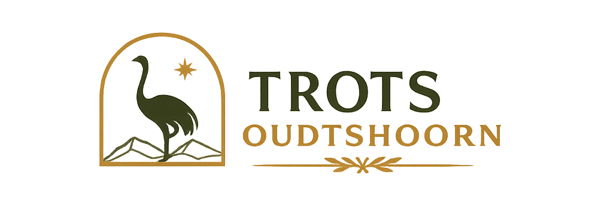
Grow Your Visibility with Trots Oudtshoorn
Pricing & Services
Every business is different. Some of you just need people to know you exist. Others want to be impossible to miss. And some of you simply don't have time to keep posting your own deals and specials. Wherever you are, there's a way for us to help — here's what we offer, and how we tailor it to fit.

Getting Listed Is Free
Your basic business listing on Trots Oudtshoorn costs nothing — no catch, no expiry. Every business in Oudtshoorn deserves to be found, and that starts free.

Founding Businesses — Limited to the First 50
The first 50 businesses to sign up become Founding Businesses, marked with an exclusive badge that stays on your listing for good. It's how we recognize the businesses that backed Trots Oudtshoorn early — and it's not something new sign-ups can get later, once the 50 spots are gone.

Try Before You Pay
Verified Badge — free for your first year
Every business gets the gold verification checkmark at no cost for a full 12 months from sign-up.
Promoted & Featured — free for your first 3 months
Want top placement, Facebook exposure, and the full visibility package? Try either completely free for 3 months from your sign-up date. No cost, no commitment.

Once You're Ready to Upgrade
Verified Badge — R150 / year
A gold verification checkmark that tells customers browsing the directory you're a real, trusted business. Low cost, easy credibility.
Promoted Listing — R250 / month
For businesses that want to stay consistently visible: priority placement in your category, a "Promoted" badge, a spot in our homepage Promoted Businesses row, and weekly ad rotation on the Trots Oudtshoorn Facebook page and groups — all included for the month.
Featured Business — R450 / month
Our top tier — for businesses that want to be seen first, including inside the very campaigns that grow the app itself. Beyond top placement above every other listing and our highest "Featured" badge, when Trots Oudtshoorn runs paid Facebook and Meta campaigns to bring new users onto the app, your business is featured directly inside those ads. That means every rand we spend growing our audience also puts your business in front of people who've never even opened the app before — not just the customers already browsing it. Everything in Promoted is included too: priority category placement, your Promoted badge, and weekly ad rotation.
Worth knowing: running a paid Facebook/Meta campaign like this yourself typically costs R1,000–R3,000+/month in ad spend alone, before any management fees. As a Featured business, you're featured inside campaigns we're already running to grow the whole platform, for R450/month total.

Want Even More Visibility?
Running a promotion or want to spotlight something specific? Flexible add-ons on top of any tier:
Weekly Ads — R100/week (Standard) or R120/week (New/Promo/Deal)
Includes an eye-catching badge. Runs Wednesday to Wednesday.
Daily Promotions — from R35 (weekdays) up to R60 (Thu–Sat)
Feature a special on the home screen for a single day. Monday and Sunday are on us.

Don't Have Time to Keep Up? Let Us Do It For You.
We hear this often: you're busy running your business, and keeping your listing fresh with new deals, photos, or specials falls to the bottom of the list. That's what our Content & Promotion Support is for.
We'll come to you, shoot photos or video on-site, and handle submitting your specials and deals — no extra work on your end. This isn't one-size-fits-all. We'll sit down with you first to understand what you actually need — how often, what kind of content works for your business, what you want to highlight — and build a package around that.
Your first visit is on us. We'll come out, shoot some content, and you'll see exactly what we do before deciding if it's worth an ongoing package.
Pricing for ongoing visits to follow, once we've run a few sessions and understand what businesses actually need.

The Value We're Building Together
Trots Oudtshoorn isn't a static directory — it's actively growing, and every business on it grows alongside it. When we market the app, build our Facebook presence, and bring new users in, that growth isn't separate from your listing — it's built around it. Every new person who discovers Trots Oudtshoorn is a new person who can now find your business.
That means the value of being listed isn't fixed at today's numbers. As our audience grows, so does the audience already looking at what you offer — at no extra cost to you. For Promoted and Featured businesses, this compounds further: you're not just benefiting from that growth passively, you're featured directly inside the campaigns driving it.
It's also why signing on early, as a Founding Business, matters. Getting in now means growing with a smaller, expanding audience — and locking in recognition that stays with your listing as that audience scales.

Why Trots Oudtshoorn Makes Sense
- Other SA directories charge just to list you. One of the country's largest, SA Business Listings, charges around R495/year for a basic paid listing. Yours is free — permanently.
- Local chambers and directories often charge annual membership fees for a fraction of what you get here, with none of the ongoing visibility, Facebook exposure, or app presence included.
- Running your own Facebook/Meta ads costs more on its own. Even a bare-minimum DIY campaign runs R1,000–R3,000/month in ad spend alone, before paying anyone to manage it. Featured includes being part of the campaigns Trots Oudtshoorn runs to grow the app — all for R450/month.

Let's Talk
Every business here is different, and our goal is to build something that fits how you work — not push you into a package that doesn't. Not sure which option makes sense for you? Let's have a quick conversation about what you're trying to achieve, and we'll figure out the right fit together.

